Azure Assignment

(AZ – 104- Module 5)

Avishekh Sinha

# MODULE 5 – Web App and Container Services

## ASSIGNMENT -1

1. INSTALL A DOCKER USING VM.
2. PULL HSHAR/WEBAPP (https://hub.docker.com/r/hshar/webapp) REPOSITORY
3. CREATE NEW FILE IN THIS REPOSITORY

To install Docker Runtime on a Linux VM- Run the following command

|  |  |
| --- | --- |
| UPDATE PACKAGE | sudo apt-get update |
| INSTALL DOCKER | sudu apt-get install docker.io |
| CHECK DOCKER STATUS | sudo service docker status |
| TO PULL THE REPO | sudo docker pull hshar/webapp |
| TO CHECK THE IMAGES | sudo docker images |
| TO CREATE THE DOCKER CONTAINER | sudo docker run -itd --name myapp hshar/webapp |
| TO RUN THE DOCKER CONTAINER | sudo docker exec -it myapp bash |
| CREATING NEW FILE IN THIS REPOSITORY | * Navigate to webroot directory – **cd /var/www/html** * Open the Editor to add the file **- nano index.html** * **Copy the given HTML in index.html**   Note   * 1. To save file - ctrl+s   2. To exit the editor – ctrl +x |

## ASSIGNMENT -2

1. CREATE AZURE CONTAINER REGISTRY AND CONNECT IT TO DOCKER RUNNING IN VM.
2. UPLOAD THE IMAGE YOU CREATED IN THIS AZURE TO CONTAINER REGISTRY
3. CREATE AN APP SERVICE TO THE DEPLOY THE SAME IMAGE

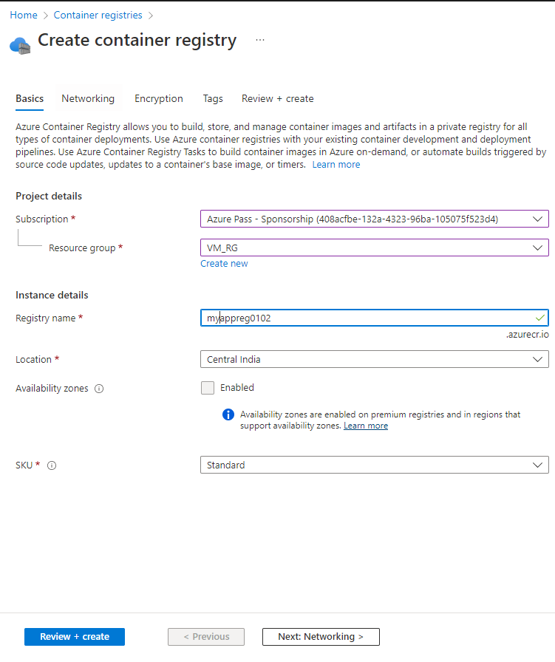

ENABLE ADMIN USER

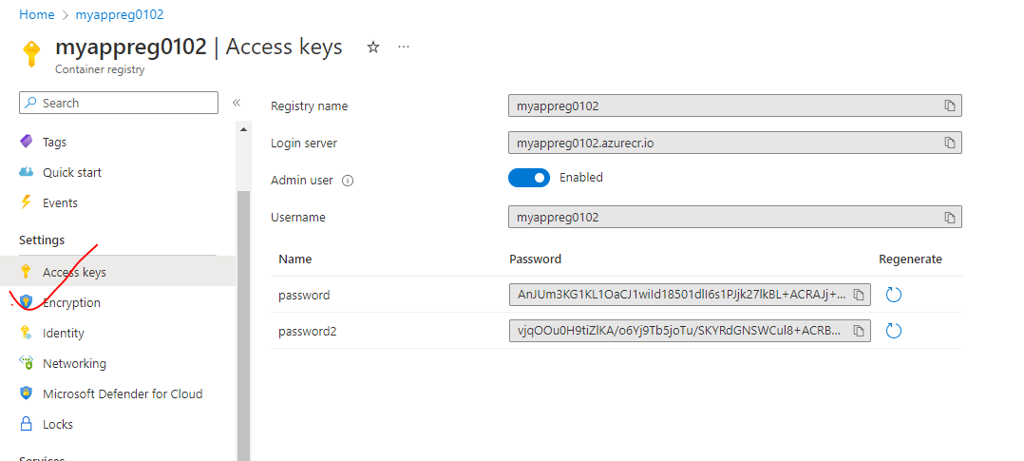

COMMITING THE CHANGES (Changes done in Assignment -1)

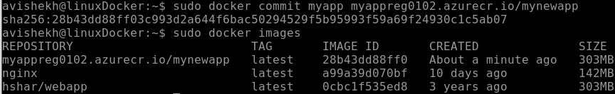

UPLOAD THE IMAGE YOU CREATED IN THIS AZURE TO CONTAINER REGISTRY

|  |  |
| --- | --- |
| LOGIN TO ACR | sudo docker login <acr_login_server>  **sudo docker push myappreg0102.azurecr.io/mynewapp** |
| PUSH IMAGE TO ACR | **sudo docker push myappreg0102.azurecr.io/mynewapp** |
| IMAGE IN ACR |  |

CREATE AN APP SERVICE TO THE DEPLOY THE SAME IMAGE

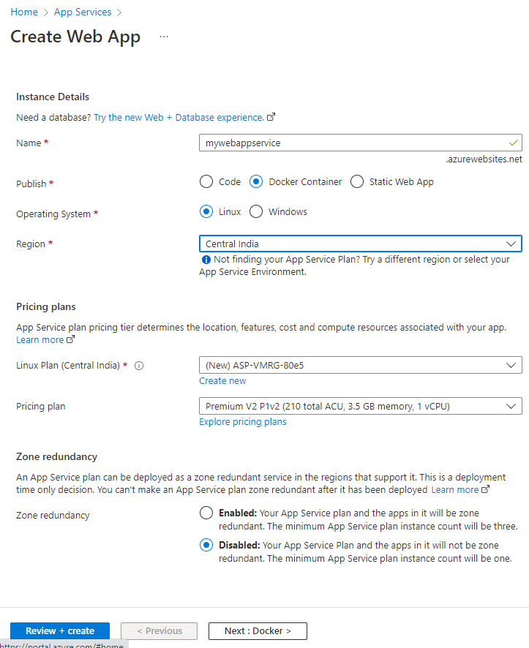

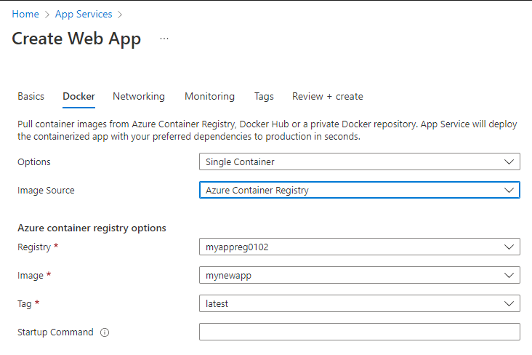

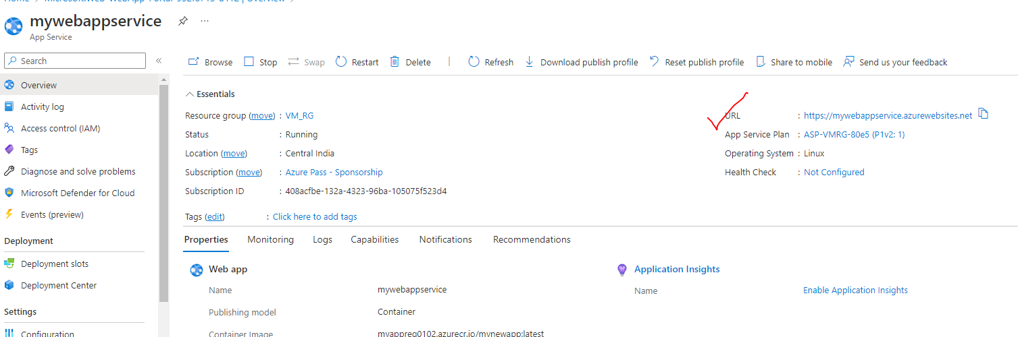

ACCESSING WEB APP

URL – <https://mywebappservice.azurewebsites.net/>

